# **Textgenrnn**

Textgenrnn is a pretrained model I found on github made by minimaxir. I got the model up and running and made a python script to interface with the model. The following is an explanation of how to get my interface running so you can easily use the model. The model itself can be found at <https://github.com/minimaxir/textgenrnn> and the methods for interface that I made can be found here <https://github.com/minimaxir/textgenrnn/blob/master/docs/textgenrnn-demo.ipynb>

## Using the interface

The interface I created is a simple python script to interact with the model. (the interface can be downloaded from my github: <https://github.com/Savorok/Computer-Science-Chalenges--40259070>)

Step 1 – Create a venv in anaconda using python 3.7

Step 2 – install the following modules to the venv:

H5py

Scikit-learn

Tqdm

Tensorflow==2.1.0

Step 3 – Cd to the folder containing my script and call the following command in terminal



Step 4 – The main menu should now load and you will be greeted with this menu

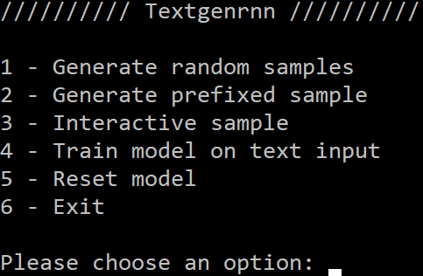

## Interface options

1 – Generate random samples

This will generate a chosen number of random samples

2 - Generate prefixed samples

This will let you generate a chosen number of samples with a prefix of your choice

3 - interactive sample

This will let you generate samples yourself by giving you the top N choices the model has for the next part of the sample

4 - train model on text input

Will let you train the model on your own dataset

5 - reset model

Will reset the model back to its pretrained state

6 – Exit

Will close the script and return you to the console